WOMENOLOGY

A COMBINATION OF WOMAN AND TECHNOLOGY

LOLA: LOGO

INSPIRING:

* SPLASH PAGE – ROTATING CAROUSEL –LOLA FIND IMAGES & SEND TO LUCY
* 4 ROUNDED IMAGES – MODAL IMAGES – LARGE – KATIE X3 LINES PER PERSON
* SUGGEST A WOMEN – KATIE COMMENT BOX

NEWS:

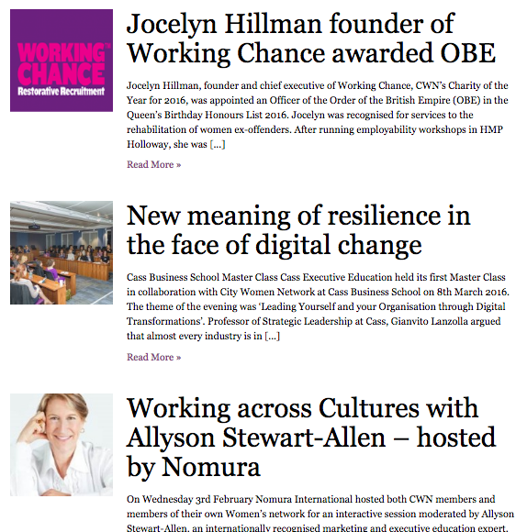

ANGE – 4-6 NEWS FEEDS

START CODING:

* LUCY HAS GOT IT COVERED – NINA AND LUCY WILL CONSOLIDATE

EVENTS AND MEETINGS:

* NINA HAS GOT IT COVERED
* ‘MAKE CALENDER’ – ADAPT CALENDER TO FIT IN WITH YOUR EVENTS

Subscribe:

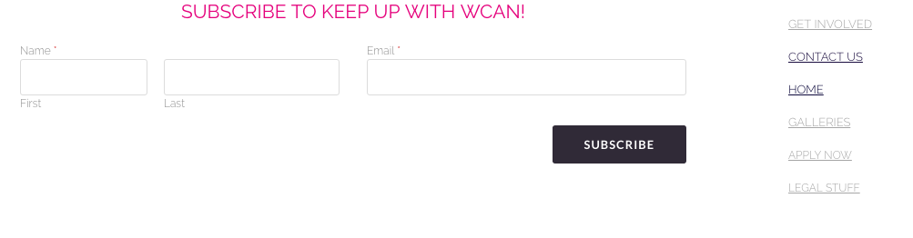

LOLA – GET IT DONE GAL!!!

Social Widgets @copyright 2016 – LOLA

* About us – names/pics/titles
* Twitter feed

BRAND GUIDELINES

Main Body: 12

Headings: 18 & Strong

Text: Centred

Images: Rounded Squares and black borders

Questions

1. How to use github – demo?